**MONDAY COFFEE REPORT**

**--Reports and Data Analysis**

**--(1) Coffee Consumers Count**

**--How many people in each city are estimated to consume coffee, given that 25% of the population does?**

select

city_name,

round((population*0.25)/1000000,2)as coffee_consumers_in_millions,

city_rank

from city

order by 2 desc

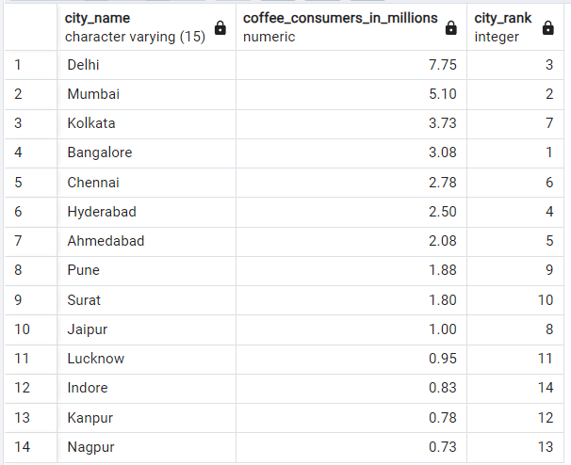

**--(2) Total Revenue from Coffee Sales**

**--What is the total revenue generated from coffee sales across all cities in the last quarter of 2023?**

select

c.city_name,

sum(s.total)as total_revenue

from sales as s

join customers as cu

on cu.customer_id=s.customer_id

join city as c

on c.city_id=cu.city_id

where

extract(year from sale_date)='2023'

and

extract(quarter from sale_date)='4'

group by 1

order by 2 desc

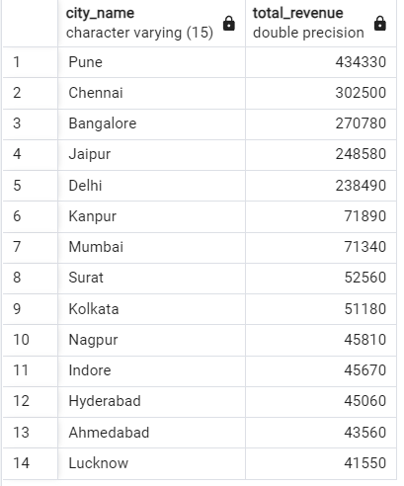

**--(3) Sales Count for Each Product**

**--How many units of each coffee product have been sold?**

select

p.product_name,

count(sale_id)as total_orders

from products as p

join sales as s

on s.product_id=p.product_id

group by 1

order by 2 desc

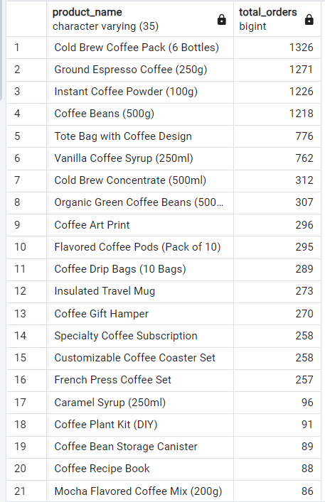

**--(4) Average Sales Amount per City**

**--What is the average sales amount per customer in each city?**

select

c.city_name,

sum(s.total)as total_revenue,

count(distinct s.customer_id)as total_customers,

round(sum(s.total)::numeric/count(distinct s.customer_id)::numeric,2)as average_sale_per_customer

from sales as s

join customers as cu

on cu.customer_id=s.customer_id

join city as c

on c.city_id=cu.city_id

group by 1

order by 4 desc

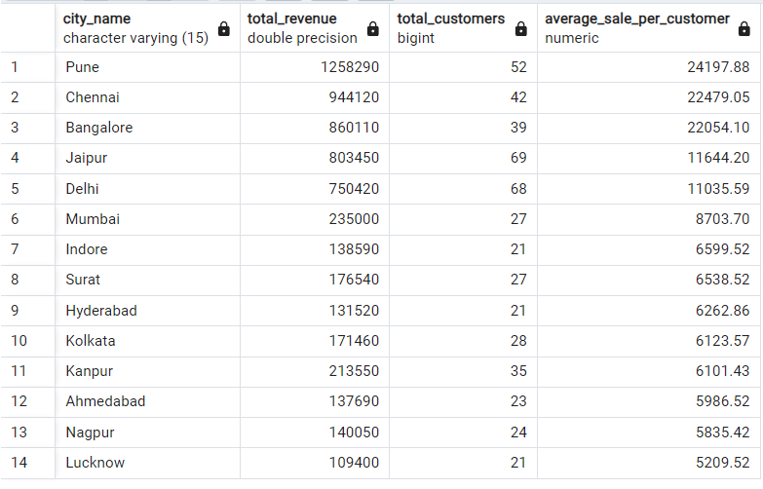

**--(5) City Population and Coffee Consumers**

**--Provide a list of cities along with their populations and estimated coffee consumers?**

select

c.city_name,

round((c.population*0.25)/1000000,2)as coffee_consumers,

count(distinct cu.customer_id)as unique_customer

from city as c

join customers as cu

on cu.city_id=c.city_id

group by 1,2

order by 1

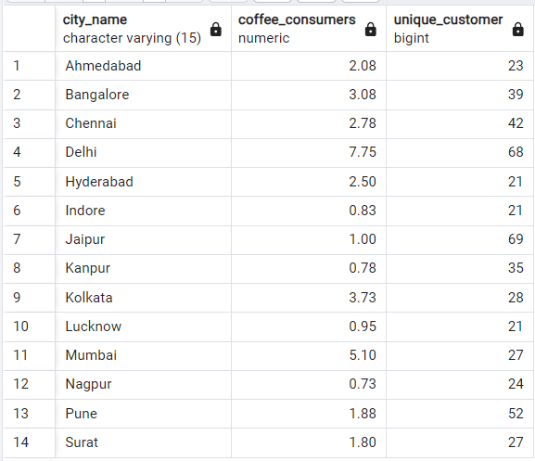

**--(6) Top Selling Products by City**

**--What are the top 3 selling products in each city based on sales volume?**

with t1 as

(

select

c.city_name,

p.product_name,

count(s.sale_id)as Total_orders,

dense_rank()over(partition by c.city_name order by count(s.sale_id)desc)as rank

from sales as s

join products as p

on p.product_id=s.product_id

join customers as cu

on cu.customer_id=s.customer_id

join city as c

on c.city_id=cu.city_id

group by 1,2

)

select*from t1

where rank<=3

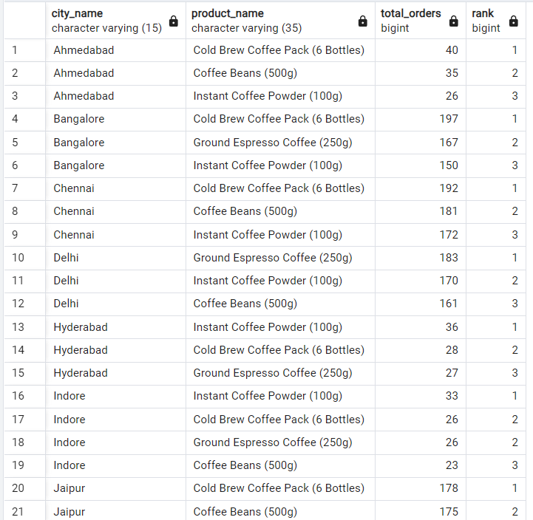

**--(7) Customer Segmentation by City**

**--How many unique customers are there in each city who have purchased coffee products?**

select

c.city_name,

p.product_name,

count(distinct cu.customer_id)as unique_customer

from sales as s

join customers as cu

on cu.customer_id=s.customer_id

join city as c

on c.city_id=cu.city_id

join products as p

on p.product_id=s.product_id

group by 1,2

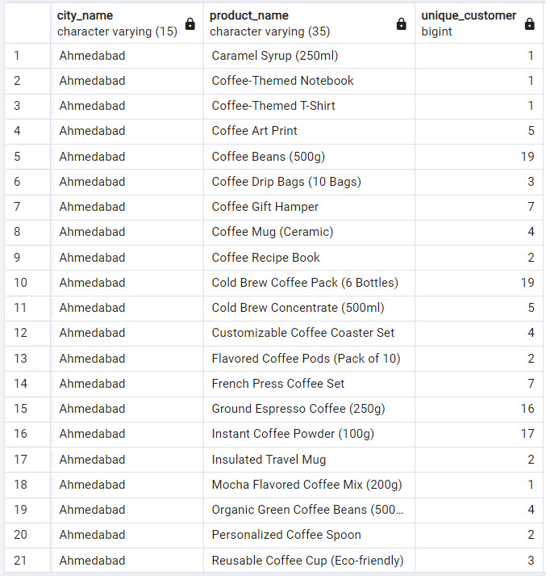

**--(8) Average Sale vs Rent**

**--Find each city and their average sale per customer and avg rent per customer?**

with city_table as

(

select

c.city_name,

sum(s.total)as total_revenue,

count(distinct s.customer_id)as total_customers,

round(sum(s.total)::numeric/count(distinct s.customer_id)::numeric,2) as average_sales_per_customer

from sales as s

join customers as cu

on cu.customer_id=s.customer_id

join city as c

on c.city_id=cu.city_id

group by 1

order by 4 desc

),

city_rent as

(

select

city_name,

sum(estimated_rent)as total_rent

from city

group by 1

)

select

city_rent.city_name,

city_rent.total_rent,

city_table.total_customers,

city_table.average_sales_per_customer,

round((city_rent.total_rent::numeric/city_table.total_customers::numeric),2)as average_rent_per_customer

from city_rent

join city_table

on city_table.city_name=city_rent.city_name

order by 5 desc

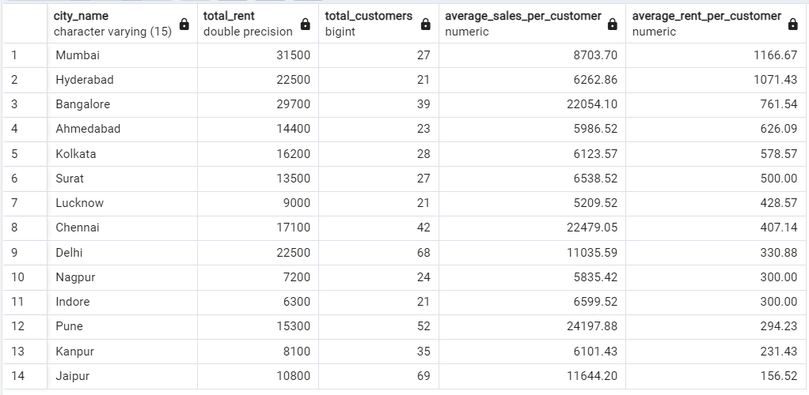

**--(9) Monthly Sales Growth**

**--Sales growth rate: Calculate the percentage growth (or decline) in sales over different time periods (monthly)?**

with monthly_sales as

(

select

c.city_name,

extract(year from s.sale_date)as year,

extract(month from s.sale_date)as month,

sum(s.total)as total_sale

from sales as s

join customers as cu

on cu.customer_id=s.customer_id

join city as c

on c.city_id=cu.city_id

group by 1,2,3

order by 1,2,3

),

growth_ratio as

(

select

city_name,

year,

month,

total_sale as current_month_sale,

lag(total_sale)over(partition by city_name order by year,month)as previous_month_sale

from monthly_sales

)

select

city_name,

year,

month,

current_month_sale,

previous_month_sale,

round((current_month_sale-previous_month_sale)::numeric/previous_month_sale::numeric*100,2)as growth_ratio

from growth_ratio

where previous_month_sale is not null

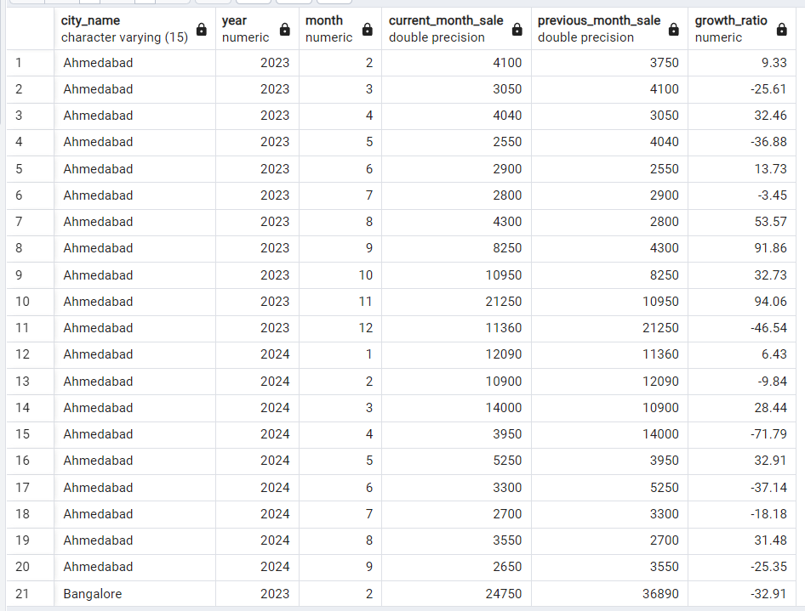

**--(10) Market Potential Analysis**

**--Identify top 3 city based on highest sales, return city name, total sale, total rent, total customers, estimated coffee consumer?**

with city_table as

(

select

c.city_name,

sum(s.total)as total_revenue,

count(distinct s.customer_id)as total_customers,

round(sum(s.total)::numeric/count(distinct s.customer_id)::numeric,2) as average_sales_per_customer

from sales as s

join customers as cu

on cu.customer_id=s.customer_id

join city as c

on c.city_id=cu.city_id

group by 1

order by 2 desc

),

city_rent as

(

select

city_name,

estimated_rent,

round((population*0.25)/1000000,3) as estimated_coffee_consumers_in_millions

from city

)

select

city_rent.city_name,

city_table.total_revenue,

city_rent.estimated_rent as total_rent,

city_table.total_customers,

city_rent.estimated_coffee_consumers_in_millions,

city_table.average_sales_per_customer,

round((city_rent.estimated_rent::numeric/city_table.total_customers::numeric),2)as average_rent_per_customer

from city_rent

join city_table

on city_table.city_name=city_rent.city_name

order by 4 desc

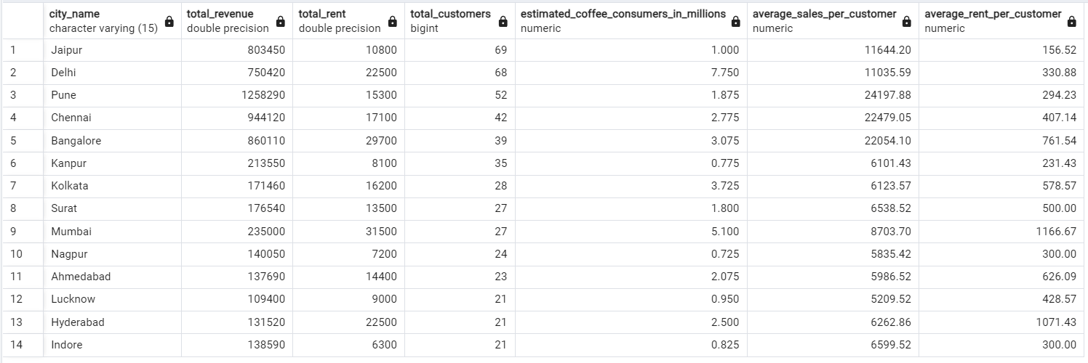

/*

**--Recommendation**

**City 1: Pune**

1. average_rent_per_customer is very less

2. highest_total_revenue

3. average_sale_per_customer is also high

**City 2: Delhi**

1. highest_estimated_coffee_comsumer which is 7.7M

2. highest total_customer which is 68

3. average_rent_per_customer is 330(still under 500)

**City 3: Jaipur**

1. highest customer no is 69

2. average_rent_per_customer is very less 156

3. average_sale_per_customer is better which is at 11.6k